**TUGAS PRAKTIKUM 2**

**WEB PROGRAMMING 2**



Disusun Oleh :

Nama : Ilham Hanif Pamulia

NIM : 18090027

Kelas : 5D

Prodi : DIV Teknik Informatika

k

**DIV TEKNIK INFORMATIKA**

**POLITEKNIK HARAPAN BERSAMA TEGAL**

**2020**

* **Materi**

1. **Latihan1.php**
2. Source Code

Latihan1.php 🡪 application/controllers

1. URL

[http://localhost/pustaka_booking_ilham5D/index.php/Latihan1/penjumlahan/16/10](http://localhost/pustaka_booking_azam/index.php/Latihan1/penjumlahan/5/10)

1. Capture Hasil

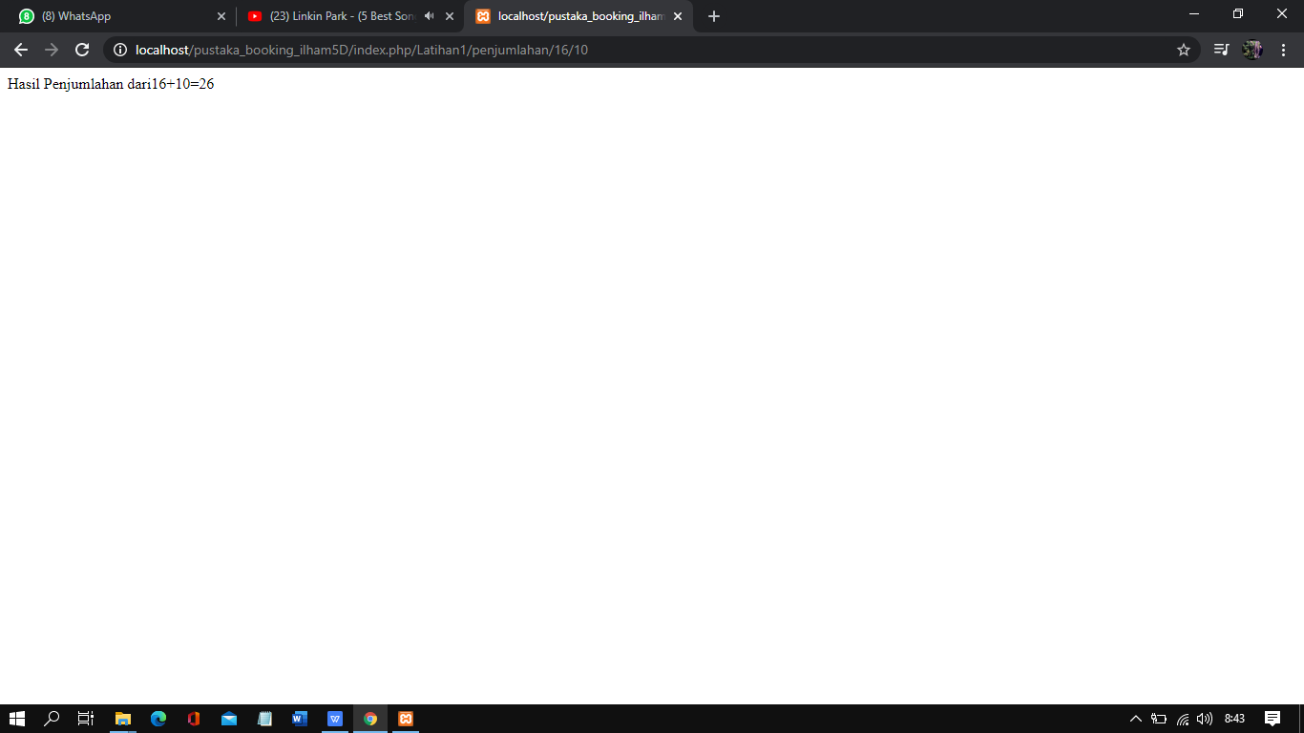

1. **Latihan2.php**
2. Source Code

Latihan2.php 🡪 application/controllers

1. URL

[http://localhost/pustaka_booking_ilham5D/index.php/Latihan2/penjumlahan/16/10](http://localhost/pustaka_booking_azam/index.php/Latihan2/penjumlahan/5/10)

1. Capture Hasil

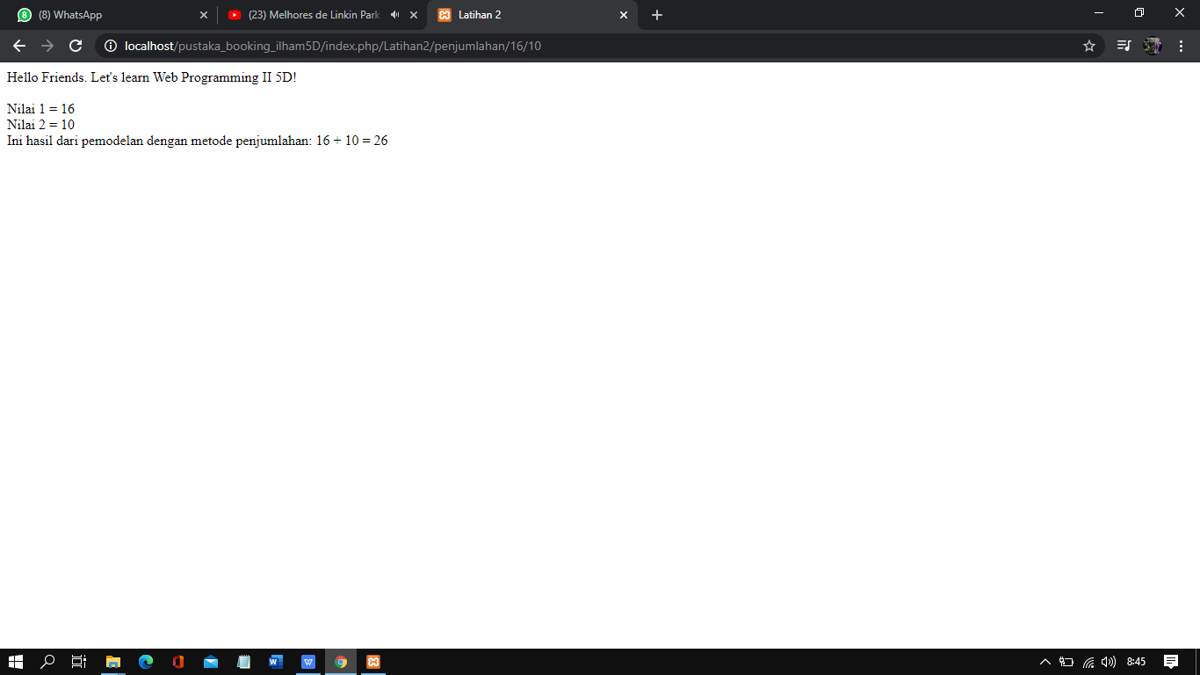

1. **Model1.php**
2. Source Code

Model1.php 🡪 application/models

1. URL

-

1. Capture Hasil

-

1. **View_latihan2.php**
2. Source Code

view-latihan2.php 🡪 application/views

1. URL

-

1. Capture Hasil

-